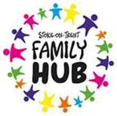
Healthy Relationships Team- Request for Support

Referrer details (including which service you are from)

Family Composition/Contact details/Address-including D.O.B of children

Is there a current early help/support plan in place for the family? if so who is the lead worker?

What are the current needs of the family?

What support does the family need from the healthy relationships team?

What changes are you hoping to see from the support?

Do both parents/child consent to this support? Y/N

